**PROJECT REPORT OF**

**SOCIAL DISTANCING DETECTOR**

**USING PYTHON, OPENCV AND DEEP LEARNING METHODS**

By

MADHURA MIRIKAR

# INTRODUCTION:

**Abstract**

**PROJECT IDEA:**

This report introduces the process of creating a social distancing detector.COVID-19 spread is emotionally challenging for many people, changing day-to-day life in unprecedented ways. All sections of society should play a vital role to protect themselves and each other and help prevent further spread of the disease. Social-distancing is an important way to slow down the spread of infectious diseases. People are asked to limit their interactions with each other, reducing the chances of the disease being spread with physical or close contact.

**SOLUTION:**

The solution is to create a system that uses pre-installed cameras/ recorded videos to analyze images from public areas like shopping malls, streets to see whether the public is adhering to safety measures, like maintaining social distancing.

This project uses python combined with deep learning and computer vision to monitor social distancing. A web application is built and is hosted on the cloud which streams the video of Social distancing Violations

**PROJECT OVERVIEW:**

Our desired result of the social distancing detector is an integrated web based application combining several current systems in use. The following are the project components:

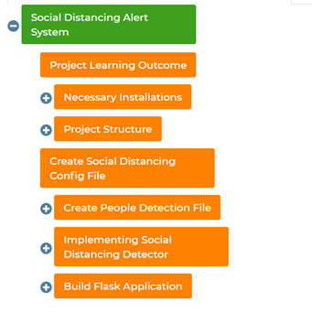

1. Necessary Installations/ Prerequisites

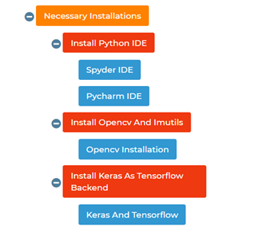

For running the application as well as for constructing the code, installation of an ideal Python IDE is required. For this project implementation **Spyder IDE** was installed on the system.

As this project is based on OpenCV techniques and also Imutils libraries, they too were installed on the python environment. Anaconda environment was used.

* **Anaconda** is a free and open-source distribution of the Python and R programming languages for scientific computing, that aims to simplify package management and deployment.
* **OpenCV** (Open Source Computer Vision Library) is an open source computer vision and machine learning software library. ... The library has more than 2500 optimized algorithms, which includes a comprehensive set of both classic and state-of-the-art computer vision and machine learning algorithms.
* **Keras** is an open-source neural-network library written in Python. It is capable of running on top of TensorFlow, Microsoft Cognitive Toolkit, R, Theano, or PlaidML. Designed to enable fast experimentation with deep neural networks
* **TensorFlow** is a free and open-source software library for dataflow and differentiable programming across a range of tasks. It is a symbolic math library, and is also used for machine learning applications such as neural networks.

2. Project Structure

In this project, we will be using Yolo object detection so all the files regarding Yolo configuration should be properly organized. The following is theprojectstructure:

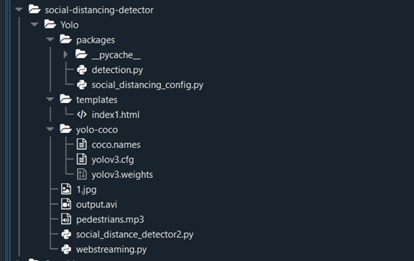

3. Social Distancing Config File

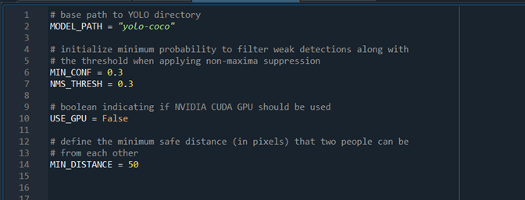

In this file, all the basic configurations required are loaded.

MODEL_PATH = “yolo-coco”

As the “yolo-coco” file is in the same directory, path was not needed to be specified. This is the base path to the YOLO directory. It needs to be mentioned because the config file is to be imported in the main project file. The main function will fetch this path as mentioned.

These are some predefined initializations. Parameters used for object detection.

#initialize minimum probability to filter weak detections

MIN_CONF = 0.3

When the system is 30% confident that this is an object, then only decide that it is an object.

#minimum safe distance (in pixels) that two people can be from each other

MIN_DISTANCE = 50

#the threshold when applying non-maxima suppression

NMS_THRESH = 0.3

4. Creating People Detection File

1. Importing libraries

The parameters from the “Social Distancing Config” file are imported. Also importing numpy and cv2 packages.

NumPy is a library for the Python programming language, adding support for large, multi-dimensional arrays and matrices, along with a large collection of high-level mathematical functions to operate on these arrays.

OpenCV-Python is a library of Python bindings designed to solve computer vision problems. All the OpenCV array structures are converted to and from Numpy arrays.

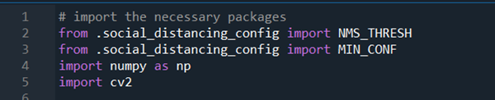

2. Creating a function for object detection

It accepts the following parameters:

**frame:** image frame from the webcam/ your video file

**net:** pre-trained YOLO weights model

**ln:** Yolo Output model layers

**personIdx:** Yolo algorithm is trained on so many objects from that we are considering people class, the index specified is especially for people class

(H, W) = grabs the dimensions of the frame to rescale the image

**results =[]** , the Yolo algorithms give 3 parameters as output which is stored in the results list variable

* Probability of detected class
* Bounding box coordinates
* Centroid of the object

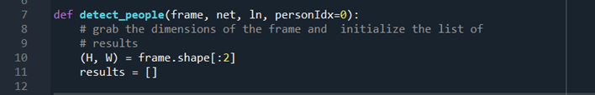

3. Perform Blob Operations

From this blob construction we will be able to perform object detection from pretrained models and the output ( 3 parameters which are discuseed earlier ) are stored in 3 list variables called boxes, confidences,centroids respectively.

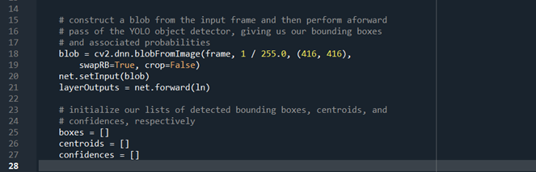

**4. Process the results**

This particular code will process the results of the variables boxes, centroids and confidences respectively.

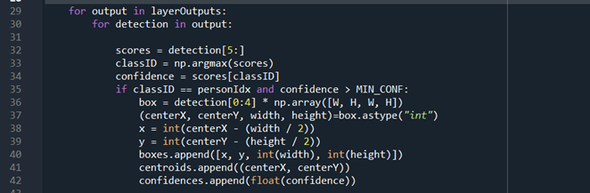

5. Applying non-maxima suppression and return the result

The purpose of non-maxima suppression is to suppress weak, overlapping bounding boxes. Line , **idxs = cv2.dnn.NMSBoxes** applies this method (it is built-in to OpenCV) and results in the idxs of the detections.

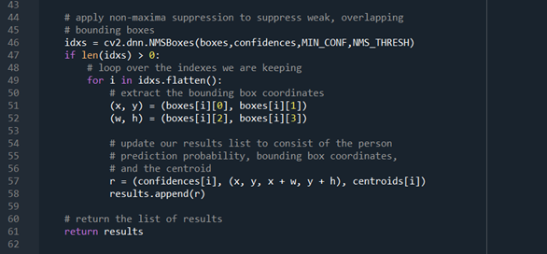

Assuming the result of NMS yields at least one detection (line if len(idxs) > 0:), we loop over them, extract bounding box coordinates, and update our results list consisting of the:

* Confidence of each person detection
* The bounding box of each person
* Centroid of each person
* Finally, we return the results to the calling function.

5. Implementing social distancing detector

**1. Import Libraries**

The packages are imported from the previous files and the normal libraries of cv2 and os.

The OS module in python provides functions for interacting with the operating system. OS, comes under Python's standard utility modules. This module provides a portable way of using operating system dependent functionality.

Imutils are a series of convenience functions to make basic image processing functions such as translation, rotation, resizing, skeletonization, and displaying Matplotlib images easier with OpenCV and both Python.

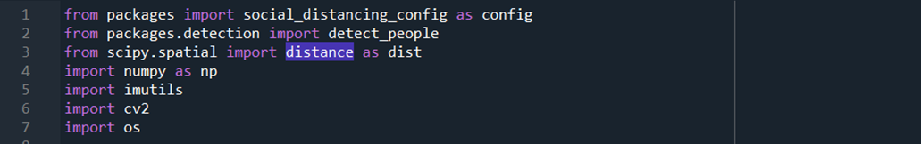

**2. Load necessary Initializations**

Here, we load our load COCO labels (labels path, Labels) as well as define our YOLO paths (weightsPath and configPath)

Using OpenCV’s DNN module, we load our YOLO net.

The CUDA GPU is used

**CUDA is a parallel computing platform and programming model that makes using a GPU for general purpose computing**

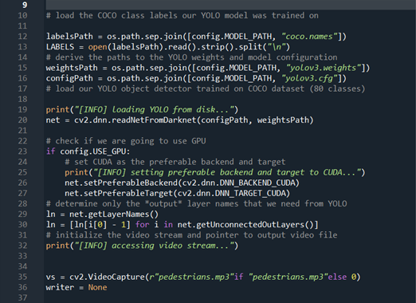

### 3. Detect Person In Frame

Loop over the frames from video stream

As the dimensions of our input video are quite large we resize the frames to maintain aspect ration

Pass the arguments to the detect function that we created earlier

Using our detect_people function implemented in the previous section, we grab results of YOLO object detection

initialize violation to set (), this declaration lists the people who violate social distance regulations

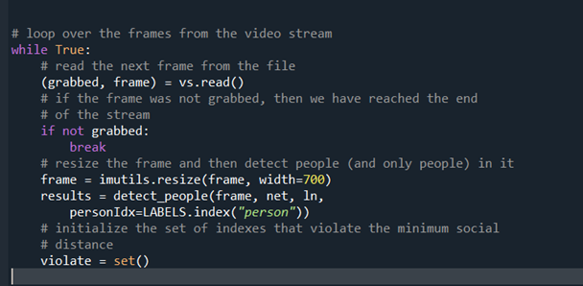

**4. Check The Distance Between Two Pedestrians**

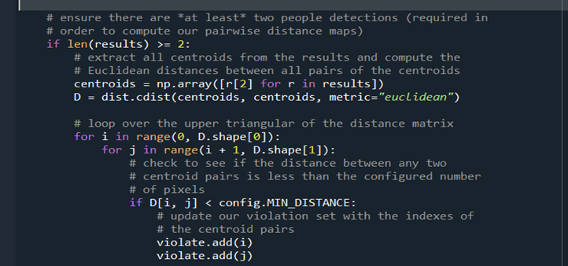

Euclidean distance- Euclidean distance or Euclidean metric is the "ordinary" straight-line distance between two points in Euclidean space. With this distance, Euclidean space becomes a metric space.

PURPOSE:

Social and physical distancing measures aim to slow the spread of disease by stopping chains of transmission of COVID-19 and preventing new ones from appearing.

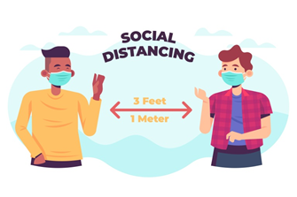

These measures secure physical distance between people (of at least one metre), and reduce contact with contaminated surfaces, while encouraging and sustaining virtual social connection within families and communities.

Since there are no vaccines available, social distancing is the only feasible approach to fight against this pandemic. Motivated by this notion, this article proposes a deep learning based framework for automating the task of monitoring social distancing using surveillance video. The proposed framework utilizes the YOLO object detection model to segregate humans from the background and Deepsort approach to track the identified people with the help of bounding boxes and assigned IDs.

The detector could highlight people whose distance is below the minimum acceptable distance in red, and draw a line between to emphasize this. The system will also be able to issue an alert to remind people to keep a safe distance if the protocol is violated.

As part of an ongoing effort to keep our customers and others safe, and understanding that the only way through this is with global collaboration, I wanted to share the technical methodology used to develop this software.

RESULTS

### **Visualize The Results**

Now visualize the video frames with violations on Opencv Window

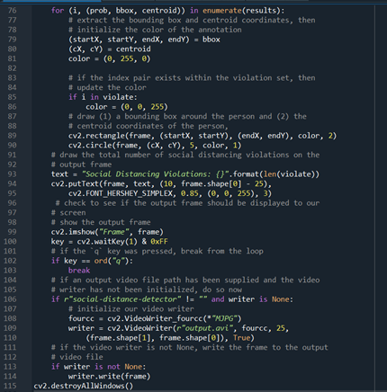

Display the frame to the screen if required, while waiting for the q (quit) key to be pressed to stop the video processing

**The Final Output**

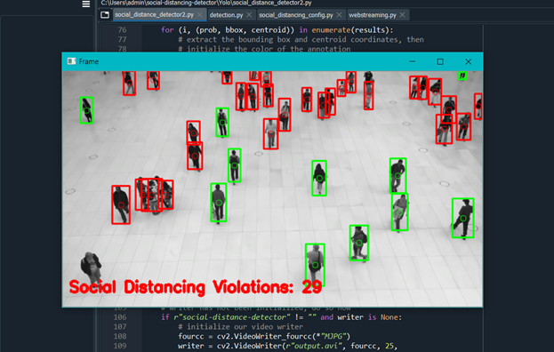

Building Flask Application and then running the app.

Flask is a lightweight WSGI web application framework. It is designed to make getting started quick and easy, with the ability to scale up to complex applications. It began as a simple wrapper around Werkzeug and Jinja and has become one of the most popular Python web application frameworks.

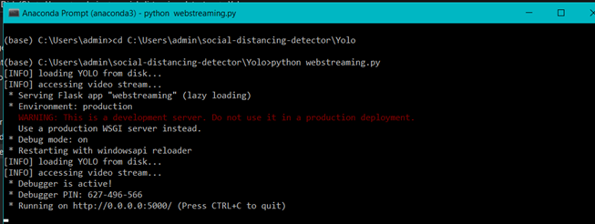

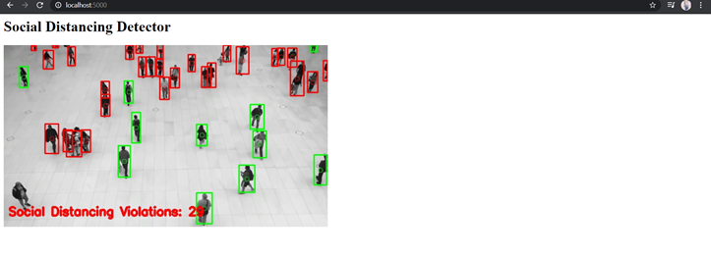

**APPLICATIONS**

## Where can we use Social Distancing AI App?

**Airports**

Social Distancing AI App can be used at airports to identify if people are maintaining social distance or not. Multiple IP cameras installed at the airport can capture people standing in close proximity and logs are kept in a system. The app triggers the voice alerts and sends notifications to the concerned authorities.

## **Hospitals**

Hospitals can use social distancing app to monitor if people are adhering to social distancing or not. Using CCTV cameras installed at hospital premises, health authorities can track if visitors, patients or health workers are maintaining a distance or not. If somebody is found violating the distancing, alerts will be sent to the concerned authorities to take action.

## **Retail shops**

Retail stores can use the social distancing AI app to ensure that visitors maintain a specific distance from each other. Cameras connected to the app would track the in-store activity and trigger voice alert to aware people. Also, retail stores can integrate a plugin into their website or app to display the live count of visitors in the store so that people can visit the store when the count is less and there is no risk of infection.

## **Public libraries**

Public libraries can use their existing CCTV or IP cameras to detect if visitors maintain a specific distance while sitting and reading in the library. If people are not found maintaining that distance, the system will trigger an alarm and alert people to create a gap to contain the risk of COVID-19.

CONCLUSION

The COVID-19 pandemic is a global health and societal emergency that requires effective and accelerated actions by all governments, businesses and communities across the world. Government agencies and businesses have found it challenging to operate in a normal or optimum environment. Many individuals don't know that they are infected with COVID-19. Social-distancing is not strictly enforced and many people are unknowingly spreading the virus.

So, this project developed using AI can help the authorities to contain the COVID19 Virus.

Using the above mentioned methods I clearly understood the OpenCV and Deep learning processes. Also, the Yolo framework was a vast topic and the instructors made it simple demonstrating examples.

FUTURE SCOPE

There is a good reason why social distancing has become such an important strategy in controlling the Covid-19 pandemic.

Each person infected with the Covid-19 coronavirus is thought to pass it on to an [average of 2-3 other people](https://cmmid.github.io/topics/covid19/current-patterns-transmission/global-time-varying-transmission.html) in the early stages of an outbreak. This contagiousness is measured by epidemiologists using something known as a “reproduction number”. By comparison, influenza has a reproduction number of [1.06-3.4 depending on the strain](https://www.medrxiv.org/content/10.1101/2020.02.04.20020404v1.full.pdf). [Spanish flu](https://bmcinfectdis.biomedcentral.com/articles/10.1186/1471-2334-14-480) was found to have a reproduction number of about 1.8 by one study. Rhinovirus, which is one of those that causes the common cold, has a reproduction number of 1.2-1.83. Most estimates for Covid-19 have put its [reproduction number at between 1.4-3.9](https://www.nejm.org/doi/10.1056/NEJMoa2001316).

This application can be used by the authorities of certain organizations to track the distancing violations and hence can contain COVID19 infections all around.

# THANKYOU